Paper Retrieval Certificate Application Form
Basic Information：
Applicant Name： |  | Applicant’s Affiliation：
Author  (the one who need the certificate): |  | Author’s Affiliation
Certificate Type: | One paper in one certificate( )  All papers in one certificate ( ) | How many copies do you need?
Tel： |  | Email：

Items included in the certificate：input√ in the corresponding grids
Paper | Retrieval Type | Collected | Total citation | Without self-citations | Self-citations | JIF Quartile | JIF | CAS JIF Quartile | Co-first Author | Highly Cited Paper | Hot Cited Paper
Web of Science Core Collection | SCIE
 | SSCI
 | A&HCI
 | CPCI-S
 | CPCI-SSH
Chinese database | CSSCI
 | CNKI
 | WanFang Data
 | VIP

Paper List：more rows could be added，Accession Number is necessary if you want the retrieval certificate of Web of Science Core Collection（SCIE、SSCI、CPCI-S、CPCI-SSH、A&HCI）！please offer the pdf of your paper if you √ Co-first Author.
No. | Title | Source | Accession Number | Co-first Author | Highly Cited Paper | Hot Cited Paper
1
2
3
4
5
6

Note：
1. Please send the form to chaxin@gzhu.edu.cn，Tel：39366270，When the certificate is ready, we will inform you through tel or email, than you can fetch the certificate at room 407, library main building.

2. How to find Accession Number
Entrance：https://www.webofscience.com/wos/alldb/basic-search
Remember to select “Web of Science Core Collection”
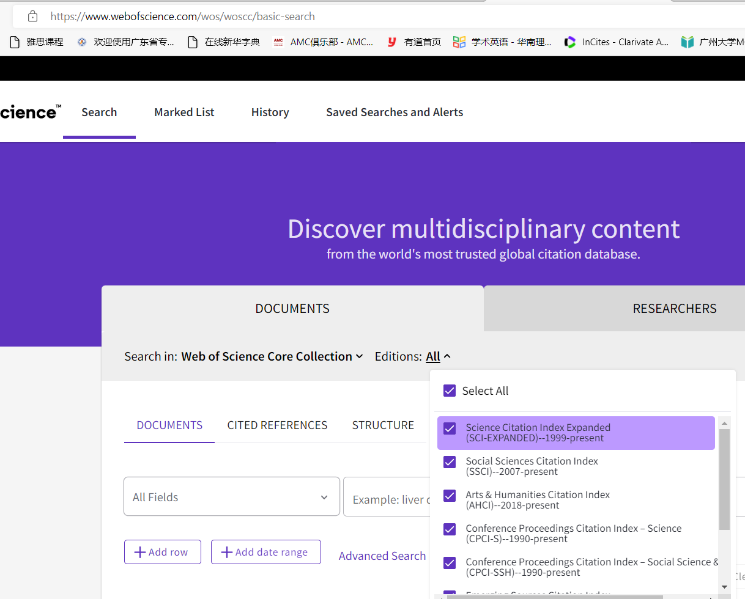

Click the link of your paper, if you cannot find the Accession Number, click “+see more data fields”
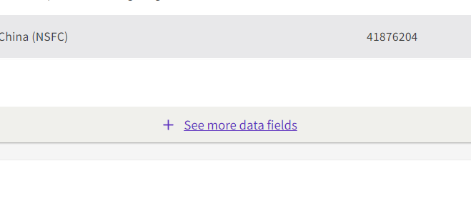
Accession Number is the second item of “document information”, copy the hilighted part(eg: WOS:000794552600001).
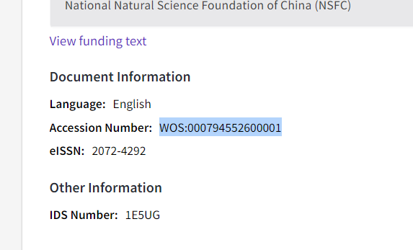

3. Payment
A Transfer from your project which begins with 5 or 6 through OA financial system.

B Scan the code（input your name in the remark part）

